Hands-On Lab
Multi-touch Game Development with XNA Framework

Lab version: 1.0.0

Contents
Overview 3
Exercise 1: Basic XNA Framework Game with Game State Management 4
Task 1 – Basic game project with game state management 5
Task 2 – Game rendering and gameplay logic 6
Exercise 2: Game polish and menus 35
Task 1 – Polishing the game – Sounds 35
Task 2 – Additional screens and menus 37
Task 3 – Keeping the HighScore 51
Task 4 – Saving/Loading game state 63
Summary 82

Overview
This lab introduces you to multi-touch enabled game development on Windows® Phone 7 using XNA Game Studio, the Windows Phone Developer tools and Visual Studio 2010.
During the course of this lab, you will build a simple 2D game using XNA Game Studio. Playing the game will require the user to supply multi-touch input, and this lab will show you how to support such input while making sure that the game reacts to multi-touch input as the user would expect.

Objectives
At the end of this lab you will have:
  - A high-level understanding of the XNA Game Studio application model within the Windows Phone 7 operating system
  - Learned how to use resources (images, fonts, etc.) in your game
  - Learned how to add game logic
  - Learned about 2D rendering in XNA Game Studio
  - Learned how to use touch and gesture input to control your game, focusing on multi-touch input

Prerequisites
The following is required in order to complete this hands-on lab:
Microsoft Visual Studio 2010 or Microsoft Visual C# Express 2010 and the Windows Phone Developer Tools, including XNA Game Studio 4.0
Previous knowledge on how to work with the XNA Game Studio 4.0 in Visual Studio 2010 to create a basic Windows Phone 7 game project. This knowledge can be acquired by performing the Catapult Wars lab located at: http://create.msdn.com/education/catalog/lab/catapult_wars

Tasks
This hands-on lab includes two excercises built from the following tasks:
  - Basic game project with game state management
  - Basic game rendering
  - Game logic
  - Polishing the game – Sound and animation
  - Additional screens and menus

Estimated time to complete this lab: 90 minutes.

Exercise 1: Basic XNA Framework Game with Game State Management
During this lab, you will build a full XNA Framework game for Windows Phone 7. The game you will build, “Memory Mandess", is a single-player game for Windows Phone 7 where the player has to repeat a color sequence displayed by the game.
Successfuly repeating the sequence progresses the game while failure throws the player back to the first level.
General Architecture
The "Memory Madness" game is built using another sample, Windows Phone Game State Management (found at http://create.msdn.com/ education/catalog/sample/game_state_management), which provides some of the assets for this lab. The game includes the following main screens:
Main menu (MainMenuScreen class)
Instructions screen (InstructionScreen class)
Playing the game (GameplayScreen class)
Paused (PauseScreen class)
HighScore screen (HighScoreScreen class)
The Game performs game-specific content loading while transitioning from the instructions screen to the gameplay screen.
When launched, the game’s first action is to load and display the background screen and then the main menu screen. Once the main menu screen is loaded, the menus animate onto the screen, after which the user can access the game itself.
We start by implementing the GameplayScreen class, presents the game itself. The other screens are discussed in the next exercise.

The completed game will look like the following:
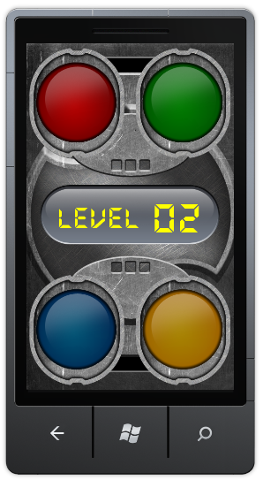
Figure 1
Memory Madness Game
Task 1 – Basic game project with game state management
In this task, you will create an XNA Framework game project for the Windows Phone 7 platform and add game state management capabilities to it by incorporating code that is supplied with this lab.
  - Create a new Windows Phone Game (4.0) project and name it MemoryMadness.
  - Open Game1.cs to change the main class name to “MemoryMadnessGame”.
  - Rename the file to match the new class name (that is, rename “Game1.cs” to “MemoryMadnessGame.cs”).
  - Add a new project folder and name it ScreenManager.
  - Select the ScreenManager project folder and add all existing files from the lab installation folder under Assets\Code\ScreenManager.
Note: All the game resources and sample code are provided in the lab installation folder in the following locations:
{LAB_PATH}\Assets\Code – all CSharp code files
{LAB_PATH}\Assets\Media – all graphics, fonts and sounds

Note: The code added in this step implements the Windows Phone Game State Management sample for creating XNA Game Studio menus and screens. It is recommended that you review this sample to better understand it. The complete sample can be found at: http://create.msdn.com/education/catalog/sample/game_state_management
Note that the code has been slightly altered for this lab.
  - Review the Solution Explorer. Your view of Solution Explorer should look like Figure 2:
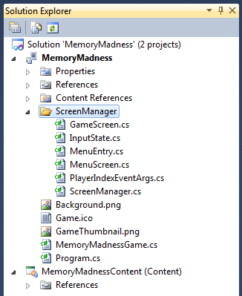
Figure 2
Solution Explorer after adding the ScreenManager folder and code
  - Build the solution it should compile without any errors.
There is no point in running the application as we have not yet altered it in any perceptible way.

Task 2 – Game rendering and gameplay logic
Having laid the groundwork for adding screens in the previous task, we can add the most important screen in the game—the gameplay screen. The real focus of this task is to add most of the initial rendering code to the game. We also delve into gameplay logic where necessary, and implement very basic versions of some of the game classes.
  - Add the lab’s resources to the game resource project. All resources are located in the lab installation folder under Assets\Media. The resource files for this lab are arranged in a directory tree structure that is helpful to preserve, so it is suggested that you add them to the content project be dragging and dropping them from the asset folder.
  - Examine Solution Explorer to see that it is similar to Figure 3.
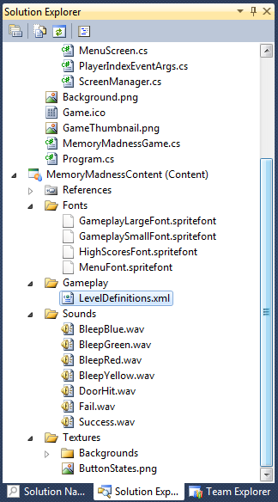
Figure 3
The content project with some of its folders expanded
  - Modify the properties of one of the newly added resources. Under MemoryMadnessContent, expand Gameplay and select LevelDefinitions.xml. Expand the Advanced section and change the Build Action property to None and the Copy to Output Directory property to Copy if newer. We perform this change because we do not need this file to be compiled and processed into another format. We will be interpreting it directly.
  - Before we move on to implementing the gameplay screen, we will add a code asset, which contains many definitions that we will need throughout our code. Create a new project folder under the MemoryMadness project and name it Misc.
  - Add exising class named Settings.cs to the Misc folder
Note: this class is provided as an asset to the lab and located at the following location:
{LAB_PATH}\Assets\Code\Misc
  - Now add the very first screen class to the project. Add a folder to the MemoryMadness project and call it Screens. You will use this project folder to store all game screen classes.
Before we start implementing the gameplay screen, let us review its general architecture.
GameplayScreen and Game Classes
Technically, the game’s update and drawing logic is contained in the GameplayScreen class. However, the GameplayScreen itself does not directly handle all of the work, as some of the work is the responsibility of the relevant game classes.
Let us review some of the game classes and their intended purpose:
  - Level: The level class encapsulates all the drawing and logic related to the current state of the game. The class keeps track of user’s progress through the level and updates the display according to the level’s state.
  - Settings: A helper class with game settings.
  - AudioManager: A helper class for playing sounds.
  - Add a new class to the MemoryMadness project under the Screens project folder and name it “GameplayScreen”.
  - Open the new class file and see that it only contains some basic "using" statements and the class definition. Replace the existing “using” statements with the following "using" statements.
You can copy & paste directly from the following code:
C#
using System;
using System.Collections.Generic;
using Microsoft.Xna.Framework;
using Microsoft.Xna.Framework.Graphics;
using GameStateManagement;
using Microsoft.Xna.Framework.GamerServices;
using System.Xml.Linq;
using Microsoft.Xna.Framework.Input.Touch;
The complexity of the gameplay screen necessitates the many using statements in the preceding code. The GameplayScreen class will eventually be capable of playing sounds, displaying graphics and responding to user input.
  - Change the new class to derive from the GameScreen class (the GameScreen class is defined in the class files we previously added to the ScreenManager folder). Also, change the namespace under which the class is defined to "MemoryMadness":
C#
namespace MemoryMadness
{
class GameplayScreen : GameScreen
{
}
}
Note: From this point forward, whenever creating a new class, always change its namespace to "MemoryMadness".
  - Add the following field definitions to the class. We use these fields for loading the textures/fonts used to draw the screen (though some will not be used until much later in the exercise) and also to control the game progress:
C#
#region Fields
private bool isLevelChange;
private bool isActive;
public new bool IsActive
{
get { return isActive; }
set
{
isActive = value;
//TODO #1
}
}
bool moveToHighScore = false;
// Gameplay variables
//TODO #2
int currentLevelNumber;
int movesPerformed = 0;
int maxLevelNumber;
// Rendering variables
SpriteFont levelNumberFont;
SpriteFont textFont;
Texture2D background;
Texture2D buttonsTexture;

// Input related variables
TimeSpan inputTimeMeasure;
TimeSpan inputGracePeriod = TimeSpan.FromMilliseconds(150);
TouchInputState inputState = TouchInputState.Idle;
List<TouchLocation> lastPressInput;
#endregion
Note: This code snippet (as well as others later in the lab) has //TODO #X statements. These statements will be replaced later during the lab.
  - Add two constructors to the class – the first will allow starting the game from a specific level and the second from a specific level and a specific position in the levels’ sequence.
C#
public GameplayScreen(int levelNumber)
{
TransitionOnTime = TimeSpan.FromSeconds(0.0);
TransitionOffTime = TimeSpan.FromSeconds(0.0);
currentLevelNumber = levelNumber;
}
public GameplayScreen(int levelNumber, int movesPerformed)
: this(levelNumber)
{
this.movesPerformed = movesPerformed;
}

Note: This flexilbility will enable us to resume the game from saved state later during the lab.
  - Create a new method and name it “LoadAssets”. This method loads the gameplay screen’s resources and initializes some of its variables:
C#
public void LoadAssets()
{
levelNumberFont =
ScreenManager.Game.Content.Load<SpriteFont>(@"Fonts\GameplayLargeFont");
textFont =
ScreenManager.Game.Content.Load<SpriteFont>(@"Fonts\GameplaySmallFont");
background =
ScreenManager.Game.Content.Load<Texture2D>(
@"Textures\Backgrounds\gameplayBG");
buttonsTexture =
ScreenManager.Game.Content.Load<Texture2D>(@"Textures\ButtonStates");
}
  - The GameScreen class defines some core game functionality matching the three states described in the exercise preface: LoadContent, Update and Draw. Override the base class’s LoadContent functionality:
C#
public override void LoadContent()
{
LoadAssets();
XDocument doc = XDocument.Load(@"Content\Gameplay\LevelDefinitions.xml");
var levels = doc.Document.Descendants(XName.Get("Level"));
foreach (var level in levels)
{
maxLevelNumber++;
}
// Resolution for a possible situation which can occur while debugging the
// game. The game may remember it is on a level which is higher than the
// highest available level, following a change to the definition file.
if (currentLevelNumber > maxLevelNumber)
currentLevelNumber = 1;

//TODO #3
base.LoadContent();
}
You may wonder why we did not simply place the code from the “LoadAssets” method inside the preceding override. The reason is that the asset loading operation is rather lengthy and in the next exercise, we see how we can introduce a loading prompt so that the game does not seem to be unresponsive. For that purpose, we want to be able to load the assets independently of the gameplay screen’s own LoadContent override.
  - Override the Draw method so that the gameplay screen will be able to draw itself onto the screen:
C#
public override void Draw(GameTime gameTime)
{
ScreenManager.GraphicsDevice.Clear(Color.CornflowerBlue);
ScreenManager.SpriteBatch.Begin();
ScreenManager.SpriteBatch.Draw(background, Vector2.Zero, Color.White);
//TODO #4
ScreenManager.SpriteBatch.End();
base.Draw(gameTime);
}
We currently have a simple Draw method, which simply draws the background texture. You will enchance it later in the lab.
  - The gameplay screen can now be made visible. To do that, we are required to alter the game class MemoryMadnessGame. Open the MemoryMadnessGame.cs file from the solution explorer and delete all content inside the MemoryMadnessGame class (but not the defined namespace or the using statements). To clarify, make sure the class looks like the following:
C#
public class MemoryMadnessGame : Game
{
}
  - Add the following using statement at the top of the class file:
C#
using GameStateManagement;
  - Add a pair of variable declarations to the beginning of the class:
C#
public class MemoryMadnessGame : Game
{
GraphicsDeviceManager graphics;
ScreenManager screenManager;
}
  - Now add a constructor to the class which will add the gameplay screen to the screen manager:
C#
public MemoryMadnessGame()
{
graphics = new GraphicsDeviceManager(this);
Content.RootDirectory = "Content";

// Frame rate is 30 fps by default for Windows Phone.
TargetElapsedTime = TimeSpan.FromTicks(333333);

//Create a new instance of the Screen Manager
screenManager = new ScreenManager(this);
Components.Add(screenManager);

// Switch to full screen for best game experience
graphics.IsFullScreen = true;

graphics.PreferredBackBufferHeight = 800;
graphics.PreferredBackBufferWidth = 480;

graphics.SupportedOrientations = DisplayOrientation.Portrait;

// Initialize sound system
//AudioManager.Initialize(this);

// TODO – start with main menu screen
GameplayScreen gameplayScreen = new GameplayScreen(1);
gameplayScreen.IsActive = true;
screenManager.AddScreen(gameplayScreen, null);

}
Note the “TODO” marker comment in the preceding code. In the next exercise, we change the code directly below it, which adds the gameplay screen to the screen manager, to add a menu screen as the initial screen instead.
Also, note that the constructor also contains a commented-out initialization of an “AudioManager” class. We will deal with this class in the next exercise (and un-comment the relevant code to initialize it).
  - Build the project and deploy it. Once the game starts, you should see a screen like that in Figure 24.
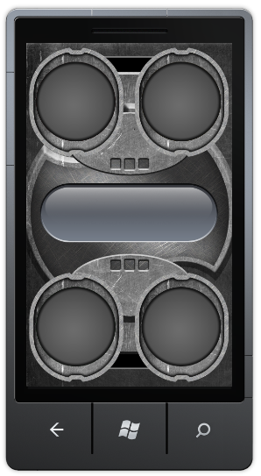
Figure 4
First look at the gameplay screen
At this point, the gameplay screen is somewhat barren, so next we add a level number display.
To do this, we also need some additional variables and functions to keep track of the information we are about to display and this is a great opportunity to introduce some of the game classes in order to encapsulate some of the information.
Our first task, therefore, will be to create a “Level” class.
  - Create a new class under the Misc project folder and name it Level.
  - At the top of the newly created class file, add the following using statements:
C#
using System.Xml.Linq;
using Microsoft.Xna.Framework;
using Microsoft.Xna.Framework.Input.Touch;
using Microsoft.Xna.Framework.Graphics;
  - Since the level will eventually be responsible for drawing itself, it could be considered a game component that can be drawn to the screen. Change the Level class to inherit from the DrawableGameComponent class:
C#
class Level : DrawableGameComponent
{
}
Note: Remember to change class’s namespace to MemoryMadness.
DrawableGameComponent is a game component that is notified when it needs to draw itself. For more information about this class, see the documentation on MSDN (http://msdn.microsoft.com/en-us/library/microsoft.xna.framework.drawablegamecomponent.aspx).
  - Add the following variable declarations to the Level class:
C#
public int levelNumber;
LinkedList<ButtonColors[]> sequence;
LinkedListNode<ButtonColors[]> currentSequenceItem;
public LevelState CurrentState;
public bool IsActive;
/// <summary>
/// The amount of moves correctly performed by the user so far
/// </summary>
public int MovesPerformed { get; set; }
// Sequence demonstration delays are multiplied by this each level
const float DifficultyFactor = 0.75f;
// Define the delay between flashes when the current set of moves is
// demonstrated to the player
TimeSpan delayFlashOn = TimeSpan.FromSeconds(1);
TimeSpan delayFlashOff = TimeSpan.FromSeconds(0.5);
// Define the allowed delay between two user inputs
TimeSpan delayBetweenInputs = TimeSpan.FromSeconds(5);
// Define the delay per move which will be used to calculate the overall time
// the player has to input the sample. For example, if this delay is 4 and the
// current level has 5 steps, the user will have 20 seconds overall to
// complete the level
readonly TimeSpan DelayOverallPerInput = TimeSpan.FromSeconds(4);
// The display period for the user's input
readonly TimeSpan InputFlashDuration = TimeSpan.FromSeconds(0.75);
TimeSpan delayPeriod;
TimeSpan inputFlashPeriod;
TimeSpan elapsedPatternInput;
TimeSpan overallAllowedInputPeriod;
bool flashOn;
bool drawUserInput;
ButtonColors?[] currentTouchSampleColors = new ButtonColors?[4];
// Define spheres covering the various buttons
BoundingSphere redShpere;
BoundingSphere blueShpere;
BoundingSphere greenShpere;
BoundingSphere yellowShpere;
// Rendering members
SpriteBatch spriteBatch;
Texture2D buttonsTexture;

These variables will give the Level class access to the game object and to a SpriteBatch that can be used for visual output and will allow it to keep track of the player’s progress.
  - Add a set of initialization methods for the Level class. Two of the methods are constructors and the third is an override of the DrawableGameComponent’s Initialize method, which is typically used for loading resources required by the component before displaying it:
C#
public Level(Game game, SpriteBatch spriteBatch, int levelNumber,
int movesPerformed, Texture2D buttonsTexture)
: base(game)
{
this.levelNumber = levelNumber;
this.spriteBatch = spriteBatch;
CurrentState = LevelState.NotReady;
this.buttonsTexture = buttonsTexture;
MovesPerformed = movesPerformed;
}
public Level(Game game, SpriteBatch spriteBatch, int levelNumber,
Texture2D buttonsTexture)
: this(game, spriteBatch, levelNumber, 0, buttonsTexture)
{ }
public override void Initialize()
{
// Update delays to match level difficulty
UpdateDelays();
// Define button bounding spheres
DefineBoundingSpheres();
// Load sequences for current level from definitions XML
LoadLevelSequences();
}

  - The Initialize method uses a number of helper methods. Add them according to the following code snippet:
C#
/// <summary>
/// Load sequences for current level from definitions XML
/// </summary>
private void LoadLevelSequences()
{
XDocument doc = XDocument.Load(@"Content\Gameplay\LevelDefinitions.xml");
var definitions = doc.Document.Descendants(XName.Get("Level"));
XElement levelDefinition = null;
foreach (var definition in definitions)
{
if (int.Parse(
definition.Attribute(XName.Get("Number")).Value) == levelNumber)
{
levelDefinition = definition;
break;
}
}

// Used to skip moves if we are resuming a level mid-play
int skipMoves = 0;
// If definitions are found, create a sequences
if (null != levelDefinition)
{
sequence = new LinkedList<ButtonColors[]>();
foreach (var pattern in
levelDefinition.Descendants(XName.Get("Pattern")))
{
if (skipMoves < MovesPerformed)
{
skipMoves++;
continue;
}
string[] values = pattern.Value.Split(',');
ButtonColors[] colors = new ButtonColors[values.Length];
// Add each color to a sequence
for (int i = 0; i < values.Length; i++)
{
colors[i] = (ButtonColors)Enum.Parse(
typeof(ButtonColors), values[i], true);
}
// Add each sequence to the sequence list
sequence.AddLast(colors);
}
if (MovesPerformed == 0)
{
CurrentState = LevelState.Ready;
delayPeriod = TimeSpan.Zero;
}
else
{
InitializeUserInputStage();
}
}
}
/// <summary>
/// Define button bounding spheres
/// </summary>
private void DefineBoundingSpheres()
{
redShpere = new BoundingSphere(
new Vector3(Settings.RedButtonPosition.X + Settings.ButtonSize.X / 2,
Settings.RedButtonPosition.Y + Settings.ButtonSize.Y / 2,
0),
Settings.ButtonSize.X / 2);
blueShpere = new BoundingSphere(
new Vector3(Settings.BlueButtonPosition.X + Settings.ButtonSize.X / 2,
Settings.BlueButtonPosition.Y + Settings.ButtonSize.Y / 2,
0),
Settings.ButtonSize.X / 2);
greenShpere = new BoundingSphere(
new Vector3(Settings.GreenButtonPosition.X + Settings.ButtonSize.X / 2,
Settings.GreenButtonPosition.Y + Settings.ButtonSize.Y / 2,
0),
Settings.ButtonSize.X / 2);
yellowShpere = new BoundingSphere(
new Vector3(Settings.YellowButtonPosition.X + Settings.ButtonSize.X / 2,
Settings.YellowButtonPosition.Y + Settings.ButtonSize.Y / 2,
0),
Settings.ButtonSize.X / 2);
}
/// <summary>
/// Update delays to match level difficulty
/// </summary>
private void UpdateDelays()
{
delayFlashOn = TimeSpan.FromTicks(
(long)(delayFlashOn.Ticks *
Math.Pow(DifficultyFactor, levelNumber - 1)));
delayFlashOff = TimeSpan.FromTicks(
(long)(delayFlashOff.Ticks *
Math.Pow(DifficultyFactor, levelNumber - 1)));
}
/// <summary>
/// Sets various members to allow the user to supply input.
/// </summary>
private void InitializeUserInputStage()
{
elapsedPatternInput = TimeSpan.Zero;
overallAllowedInputPeriod = TimeSpan.Zero;
CurrentState = LevelState.Started;
drawUserInput = false;
// Calculate total allowed timeout period for the entire level
overallAllowedInputPeriod = TimeSpan.FromSeconds(
DelayOverallPerInput.TotalSeconds * sequence.Count);
}
The “LoadLevelSequences” method uses the XML file supplied as an asset to this lab in order to load the level sequence. Locate the file in the MemoryMadnessContent project in Gameplay folder. Open and examine LevelDefinitions.xml file. The file defines the levels and sequences as follows (partial definitions):
XML
<?xml version="1.0" encoding="utf-8" ?>
<Levels>
<Level Number="1">
<Pattern Id="1">Red</Pattern>
</Level>
<Level Number="2">
<Pattern Id="1">Red</Pattern>
<Pattern Id="2">Green</Pattern>
</Level>
<Level Number="3">
<Pattern Id="1">Red</Pattern>
<Pattern Id="2">Green</Pattern>
<Pattern Id="3">Yellow,Blue</Pattern>
</Level>

...

</Levels>
Note: The file contents may vary from those presented in the lab document, but the file’s structure will be the same. It defines the levels, with each level composed of several patterns which serve as steps to present during each level. A pattern could be a single color (“Green” or “Yellow”) or multiple colors separated by comma (“Green,Red”).
Note: The provided file has two different level definitions - one with a single color in each step and one with multiple colors in some of the steps. If you are performing this lab on multi-touch enabled PC with the Emulator or using a real Windows Phone 7 device, you may use both level definitions according to your preference. If you are using the Emulator with mouse input on a PC, please use the single-touch scenario.
  - During the Update stage of the game loop, we want the Level to act according to its current state:
  - If the the level is ready (fully loaded) then the user should see the level steps flashing on the screen.
  - After the flashing sequence, the level awaits for user input.
  - If the user is not quick enough, the level is failed.
  - If the user entered a wrong sequence, the level is failed.
  - If the user entered the correct sequence within a given amount of time, the level is passed (and will be progressed to the next level by the GameplayScreen later in this task).
To achieve this behavior, we override Update method of the Level class:
C#
public override void Update(GameTime gameTime)
{
if (!IsActive)
{
base.Update(gameTime);
return;
}
switch (CurrentState)
{
case LevelState.NotReady:
break;
case LevelState.Ready:
break;
case LevelState.Flashing:
break;
case LevelState.Started:
break;
case LevelState.InProcess:
break;
case LevelState.Fault:
break;
case LevelState.Success:
break;
case LevelState.FinishedOk:
break;
case LevelState.FinishedFail:
break;
default:
break;
}
base.Update(gameTime);
}

  - Replace the “Ready” case with the following code snippet:
C#
delayPeriod += gameTime.ElapsedGameTime;
if (delayPeriod >= delayFlashOn)
{
// Initiate flashing sequence
currentSequenceItem = sequence.First;
//TODO #5
CurrentState = LevelState.Flashing;
delayPeriod = TimeSpan.Zero;
flashOn = true;
}
break;
Note: By “replacing” a specific case, we mean to use the snippet as its implementation, and not to delete the case statement (in the above step, the snippet should still be preceded by the line “case LevelState.Ready:”.
  - Replace the “Flashing” case with the following code snippet:
C#
// Display the level's move set. When done, start accepting
// user input
delayPeriod += gameTime.ElapsedGameTime;
if ((delayPeriod >= delayFlashOn) && (flashOn))
{
delayPeriod = TimeSpan.Zero;
flashOn = false;
}
if ((delayPeriod >= delayFlashOff) && (!flashOn))
{
delayPeriod = TimeSpan.Zero;
currentSequenceItem = currentSequenceItem.Next;
//TODO #6
flashOn = true;
}
if (currentSequenceItem == null)
{
InitializeUserInputStage();
}
break;
  - Delete the “break;” statement under the “Started” case to have it behave like the “InProcess” case.
  - Replace the “InProcess” case with the following code snippet:
C#
delayPeriod += gameTime.ElapsedGameTime;
inputFlashPeriod += gameTime.ElapsedGameTime;
elapsedPatternInput += gameTime.ElapsedGameTime;
if ((delayPeriod >= delayBetweenInputs) ||
(elapsedPatternInput >= overallAllowedInputPeriod))
{
// The user was not quick enough
inputFlashPeriod = TimeSpan.Zero;
CurrentState = LevelState. FinishedFail;
}
if (inputFlashPeriod >= InputFlashDuration)
{
drawUserInput = false;
}
break;
  - Replace the “Fault” case with the following code snippet:
C#
inputFlashPeriod += gameTime.ElapsedGameTime;
if (inputFlashPeriod >= InputFlashDuration)
{
drawUserInput = false;
CurrentState = LevelState.FinishedFail;
}
break;
  - Finally, replace the “Success” case with the following code snippet:
C#
inputFlashPeriod += gameTime.ElapsedGameTime;
if (inputFlashPeriod >= InputFlashDuration)
{
drawUserInput = false;
CurrentState = LevelState.FinishedOk;
}
break;
  - In order to visualize the sequence and current user input the level class should draw the color button texutres at their corresponding positions over the background. The “darken” and “lit” textures will be presented according to the current state of the level. Override the “Draw” method of the Level class according to the following code snippet:
C#
public override void Draw(GameTime gameTime)
{
if (IsActive)
{
spriteBatch.Begin();
// Define button's positions
Rectangle redButtonRectangle = Settings.RedButtonDim;
Rectangle greenButtonRectangle = Settings.GreenButtonDim;
Rectangle blueButtonRectangle = Settings.BlueButtonDim;
Rectangle yellowButtonRectangle = Settings.YellowButtonDim;
// Draw the darkened buttons
DrawDarkenedButtons(redButtonRectangle, greenButtonRectangle,
blueButtonRectangle, yellowButtonRectangle);
switch (CurrentState)
{
case LevelState.NotReady:
case LevelState.Ready:
break;
case LevelState.Flashing:
case LevelState.Started:
case LevelState.InProcess:
case LevelState.Fault:
case LevelState.Success:
break;
case LevelState.FinishedOk:
break;
case LevelState.FinishedFail:
break;
default:
break;
}
spriteBatch.End();
}
base.Draw(gameTime);
}
Note: The above method is not in its finite state and we will revise it soon.
  - The code snippet uses a helper function in order to draw buttons in their darkened states. Create the function “DrawDarkenedButtons” according to the following code snippet:
C#
private void DrawDarkenedButtons(Rectangle redButtonRectangle,
Rectangle greenButtonRectangle, Rectangle blueButtonRectangle,
Rectangle yellowButtonRectangle)
{
spriteBatch.Draw(buttonsTexture, Settings.RedButtonPosition,
redButtonRectangle, Color.White);
spriteBatch.Draw(buttonsTexture, Settings.GreenButtonPosition,
greenButtonRectangle, Color.White);
spriteBatch.Draw(buttonsTexture, Settings.BlueButtonPosition,
blueButtonRectangle, Color.White);
spriteBatch.Draw(buttonsTexture, Settings.YellowButtonPosition,
yellowButtonRectangle, Color.White);
}

  - As we have previously mentioned, the level’s “Draw” cycle needs to draw a lit button texture in some cases. These textures will be drawn over the dark textures, hiding them. In order to draw lit textures add the “DrawLitButtons” method to the class:
C#
private void DrawLitButtons(ButtonColors[] toDraw)
{
Vector2 position = Vector2.Zero;
Rectangle rectangle = Rectangle.Empty;
for (int i = 0; i < toDraw.Length; i++)
{
switch (toDraw[i])
{
case ButtonColors.Red:
position = Settings.RedButtonPosition;
rectangle = Settings.RedButtonLit;
break;
case ButtonColors.Yellow:
position = Settings.YellowButtonPosition;
rectangle = Settings.YellowButtonLit;
break;
case ButtonColors.Blue:
position = Settings.BlueButtonPosition;
rectangle = Settings.BlueButtonLit;
break;
case ButtonColors.Green:
position = Settings.GreenButtonPosition;
rectangle = Settings.GreenButtonLit;
break;
}
spriteBatch.Draw(buttonsTexture, position, rectangle, Color.White);
}
}
  - This method should be executed at certain states during the Draw cycle. Add the following code snippet to the “Flashing” case inside the “Draw” method previously overridden:
C#
if ((currentSequenceItem != null) && (flashOn))
{
ButtonColors[] toDraw = currentSequenceItem.Value;
DrawLitButtons(toDraw);
}
break;
  - And the following code snippet to the “Success” case inside the “Draw” method. This will be used to properly flash the latest user input just before advancing to the next level:
C#
if (drawUserInput)
{
List<ButtonColors> toDraw =
new List<ButtonColors>(currentTouchSampleColors.Length);
foreach (var touchColor in currentTouchSampleColors)
{
if (touchColor.HasValue)
{
toDraw.Add(touchColor.Value);
}
}
DrawLitButtons(toDraw.ToArray());
}
break;
Now that our level class is ready, it is time to utilize it in GameplayScreen.
  - Open the file GameplayScreen.cs located inside the Screens project folder and locate “//TODO #1”. Replace it with the following code snippet:
C#
if (null != currentLevel)
currentLevel.IsActive = value;
Note: The lab includes code that is the result of this exercise. The “TODO” comments are not removed in that code, and instead snippets such as above are added directly beneath the comments.
  - Locate “//TODO #2” and replace it with the following variable declaration:
C#
public Level currentLevel;
  - Create a helper method “InitializeLevel” in the GameplayScreen class according to the following code snippet:
C#
private void InitializeLevel()
{
currentLevel = new Level(ScreenManager.Game,
ScreenManager.SpriteBatch,
currentLevelNumber, movesPerformed, buttonsTexture);
currentLevel.IsActive = true;
ScreenManager.Game.Components.Add(currentLevel);
}

  - Locate the “//TODO #3” statement and replace it with the “InitializeLevel” method call:
C#
InitializeLevel();

  - Create an additional helper method named “DrawLevelText”. This method will display the text in the middle of gameplay screen according to the current level state:
C#
private void DrawLevelText()
{
if (IsActive)
{
string text;
Vector2 size;
Vector2 position;
if (currentLevel.CurrentState == LevelState.NotReady)
{
text = "Preparing...";
size = textFont.MeasureString(text);
position = new Vector2(
(ScreenManager.GraphicsDevice.Viewport.Width - size.X) / 2,
(ScreenManager.GraphicsDevice.Viewport.Height - size.Y) / 2);
position.X += 20f;
ScreenManager.SpriteBatch.DrawString(textFont, text,
position, Color.White, 0f, Vector2.Zero, 0.9f,
SpriteEffects.None, 0f);
}
else
{
Color levelColor = Color.White;
switch (currentLevel.CurrentState)
{
case LevelState.NotReady:
case LevelState.Ready:
break;
case LevelState.Flashing:
levelColor = Color.Yellow;
break;
case LevelState.Started:
case LevelState.Success:
case LevelState.InProcess:
case LevelState.FinishedOk:
levelColor = Color.LimeGreen;
break;
case LevelState.Fault:
case LevelState.FinishedFail:
levelColor = Color.Red;
break;
default:
break;
}
// Draw "Level" text
text = "Level";
size = textFont.MeasureString(text);
position = new Vector2(70, (
ScreenManager.GraphicsDevice.Viewport.Height - size.Y) / 2);
ScreenManager.SpriteBatch.DrawString(
textFont, text, position, levelColor);
// Draw level number
text = currentLevelNumber.ToString("D2");
size = levelNumberFont.MeasureString(text);
position = new Vector2(290, (
ScreenManager.GraphicsDevice.Viewport.Height - size.Y) / 2);
ScreenManager.SpriteBatch.DrawString(
levelNumberFont, text, position, levelColor);
}
}
}

  - Locate last “//TODO #4” statement and replace it with a new method call :
C#
DrawLevelText();
  - Compile and deploy the project. You should now see the an image like Figure 25.
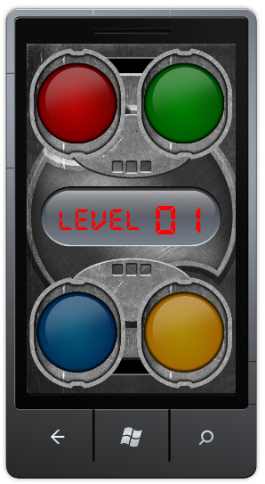
Figure 5
The gameplay screen, with the color buttons
The level should light the first button according to the defined sequence. While the game screen now contains much more information, it is still missing a key aspect – the user input. We now focus on adding this input to the Level class and changing the GamePlayScreen to support the game’s logic.
  - Open the “Level” class and add the following method:
C#
public void RegisterTouch(List<TouchLocation> touchPoints)
{
if ((CurrentState == LevelState.Started ||
CurrentState == LevelState.InProcess))
{
ButtonColors[] stepColors = sequence.First.Value;
bool validTouchRegistered = false;
if (touchPoints.Count > 0)
{
// Reset current touch sample
for (int i = 0; i < Settings.ButtonAmount; i++)
{
currentTouchSampleColors[i] = null;
}
// Go over the touch points and populate the current touch sample
for (int i = 0; i < touchPoints.Count; i++)
{
var gestureBox = new BoundingBox(
new Vector3(touchPoints[i].Position.X - 5,
touchPoints[i].Position.Y - 5, 0),
new Vector3(touchPoints[i].Position.X + 10,
touchPoints[i].Position.Y + 10, 0));
if (redShpere.Intersects(gestureBox))
{
currentTouchSampleColors[i] = ButtonColors.Red;
// TODO #1
}
else if (yellowShpere.Intersects(gestureBox))
{
currentTouchSampleColors[i] = ButtonColors.Yellow;
// TODO #2
}
else if (blueShpere.Intersects(gestureBox))
{
currentTouchSampleColors[i] = ButtonColors.Blue;
// TODO #3
}
else if (greenShpere.Intersects(gestureBox))
{
currentTouchSampleColors[i] = ButtonColors.Green;
// TODO #4
}
CurrentState = LevelState.InProcess;
}
List<ButtonColors> colorsHit =
new List<ButtonColors>(currentTouchSampleColors.Length);
// Check if the user pressed at least one of the colored buttons
foreach (var hitColor in currentTouchSampleColors)
{
if (hitColor.HasValue)
{
validTouchRegistered = true;
colorsHit.Add(hitColor.Value);
}
}
// Find the buttons which the user failed to touch
List<ButtonColors> missedColors =
new List<ButtonColors>(stepColors.Length);
foreach (var stepColor in stepColors)
{
if (!colorsHit.Contains(stepColor))
{
missedColors.Add(stepColor);
}
}
// If the user failed to performe the current move, fail the level
// Do nothing if no buttons were touched
if (((missedColors.Count > 0) ||
(touchPoints.Count != stepColors.Length)) &&
validTouchRegistered)
{
CurrentState = LevelState.Fault;
}
if (validTouchRegistered)
{
// Show user pressed buttons, reset timeout period
// for button flash
drawUserInput = true;
inputFlashPeriod = TimeSpan.Zero;
MovesPerformed++;
sequence.Remove(stepColors);
if ((sequence.Count == 0) &&
(CurrentState != LevelState.Fault))
{
CurrentState = LevelState.Success;
}
}
}
}
}
This lengthy method accepts user touch points, then checks if the touch positions are in one of the color buttons’ area. The method then compares the pressed buttons against the level’s current expected sequence. We will activate this method from the GameplayScreen class in the following step. This is because the “GameScreen” class allows easy hooking into user input, unlike the “DrawableGameComponent” class from which the Level class inherits.
  - Open “GameplayScreen” class again and override “HandleInput” method according to the following code snippet:
C#
public override void HandleInput(InputState input)
{
if (IsActive)
{
if (input == null)
throw new ArgumentNullException("input");
if (input.IsPauseGame(null))
{
// TODO #7
}
if (input.TouchState.Count > 0)
{
// We are about to handle touch input
switch (inputState)
{
case TouchInputState.Idle:
// We have yet to receive input, start grace period
inputTimeMeasure = TimeSpan.Zero;
inputState = TouchInputState.GracePeriod;
lastPressInput = new List<TouchLocation>();
foreach (var touch in input.TouchState)
{
if (touch.State == TouchLocationState.Pressed)
{
lastPressInput.Add(touch);
}
}
break;
case TouchInputState.GracePeriod:
// Do nothing during the grace period other than
// remembering additional presses
foreach (var touch in input.TouchState)
{
if (touch.State == TouchLocationState.Pressed)
{
lastPressInput.Add(touch);
}
}
break;
default:
break;
}
}
}
}
The above code aims to make user input more forgiving. Instead of directly forwarding input to the Level class, the gameplay screen will accumulate presses over a short period, making multi-touch input less harsh. We will see how we forward this input to the level in the next step.
  - Finally, we must make the GameplayScreen class update the game state based on current level state and progress to the next level when user completes the current level’s sequence. Override the “Update” method of GameplayScreen class. The relevant method code should look like the following:
C#
public override void Update(GameTime gameTime, bool otherScreenHasFocus,
bool coveredByOtherScreen)
{
//TODO #8
if (!IsActive || moveToHighScore)
{
base.Update(gameTime, otherScreenHasFocus, coveredByOtherScreen);
return;
}
if ((inputState == TouchInputState.GracePeriod) && (isActive))
{
inputTimeMeasure += gameTime.ElapsedGameTime;
// if the input grace period is over, handle the touch input
if (inputTimeMeasure >= inputGracePeriod)
{
currentLevel.RegisterTouch(lastPressInput);
inputState = TouchInputState.Idle;
}
}
if (currentLevel.CurrentState == LevelState.FinishedOk && isActive)
{
//TODO #9
if (currentLevelNumber < maxLevelNumber)
{
currentLevelNumber++;
isLevelChange = true;
}
else
{
//TODO #10 – REPLACE
ScreenManager.Game.Exit();
}
}
else if (currentLevel.CurrentState == LevelState.FinishedFail)
{
//TODO #11
currentLevelNumber = 1;
isLevelChange = true;
}
if (isLevelChange)
{
ScreenManager.Game.Components.Remove(currentLevel);
currentLevel = new Level(ScreenManager.Game,
ScreenManager.SpriteBatch,
currentLevelNumber, buttonsTexture);
currentLevel.IsActive = true;
ScreenManager.Game.Components.Add(currentLevel);

isLevelChange = false;
}
base.Update(gameTime, otherScreenHasFocus, coveredByOtherScreen);
}
Note: The second if statement in the above code forwards the user input to the Level object once the grace period is over.
  - Compile and deploy the project. The game should now be completely playable, though lacking in polish. After navigating to the game screen, the game should display the sequence and respond to the players input.
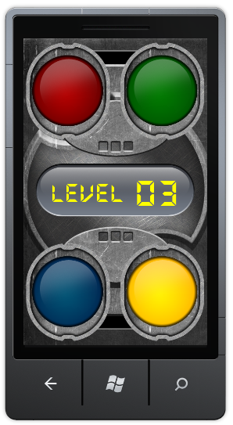
Figure 6
Gameplay screen presenting the sequence
  - This concludes the last task of this exercise. In the next exercise, we will add sounds, animations and additional screens to improve the game experience.

Exercise 2: Game polish and menus
In the previous exercise, we implemented a game with playable logic. While the game is fully playable in its current state, the game experience lacks polish. Our first task in this exercise is to improve the game’s presentation by incorporating sound.
Later in the exercise, we add additional elements that are part of the game but are not part of the actual gameplay screen. We add a main menu and an instructions screen and we give the user the ability to pause the game and display a pause screen. Additionally, we add a highscore screen to keep track of the best scores achieved in the game. Last, we will add an ability to save and resume the game state.
Task 1 – Polishing the game – Sounds
  - Add an existing code asset, the AudioManager class, to the “Misc” project folder.
Note: This class provided as an asset for the game and located in following location:
{LAB_PATH}\Assets\Code\Misc
The above class will allow us to play back sounds. We can revisit the various classes created during the previous exercise in order to enhance their functionality.
  - Open the Level.cs under the "Misc" folder and add a new method named “PlaySequenceStepSound” according to the following code snippet:
C#
private void PlaySequenceStepSound()
{
if (currentSequenceItem == null)
{
return;
}
for (int i = 0; i < currentSequenceItem.Value.Length; ++i)
{
switch (currentSequenceItem.Value[i])
{
case ButtonColors.Red:
AudioManager.PlaySound("red");
break;
case ButtonColors.Yellow:
AudioManager.PlaySound("yellow");
break;
case ButtonColors.Blue:
AudioManager.PlaySound("blue");
break;
case ButtonColors.Green:
AudioManager.PlaySound("green");
break;
default:
break;
}
}
}

This method simply plays back a sound associated with the current step inside the level.
  - Locate “RegisterTouch” method in the Level class and locate “//TODO #1” placeholder. Add the following code snippet after the placeholder:
C#
AudioManager.PlaySound("red");

  - Locate “//TODO #2” placeholder and add the following code snippet after it:
C#
AudioManager.PlaySound("yellow");

  - Locate “//TODO #3” placeholder and add the following code snippet after it:
C#
AudioManager.PlaySound("blue");
  - Locate “//TODO #4” placeholder and add the following code snippet after it:
C#
AudioManager.PlaySound("green");
  - Locate “Update” method in the Level class and locate “//TODO #5” and “//TODO #6” placeholders. Add the following code snippet after both placeholders:
C#
PlaySequenceStepSound();

  - Open the GameplayScreen.cs file and navigate to the “Update” method. Locate the “//TODO #9” and add the following code snippet after the placeholder:
C#
AudioManager.PlaySound("success");

  - Locate the “//TODO #11” and add the following line beneath it:
C#
AudioManager.PlaySound("fail");
  - Open MemoryMadnessGame.cs file and navigate to the game constructor. Locate “// Initialize sound system” comment and uncomment AudioManager initialization. The resulting code should looks like the following:
C#
...
graphics.SupportedOrientations = DisplayOrientation.Portrait;
// Initialize sound system
AudioManager.Initialize(this);
// TODO – start with main menu screen
GameplayScreen gameplayScreen = new GameplayScreen(1);
...
  - Override the “LoadContent” function of the MemoryMadnessGame class according to the following code snippet:
C#
protected override void LoadContent()
{
AudioManager.LoadSounds();
base.LoadContent();
}
  - Compile the project and deploy it. The game should now include sound in addition to being completely playable.

Task 2 – Additional screens and menus
We may have drastically improved the game experience during the previous task, but the game is not complete. When launched, the game displays the gameplay screen abruptly and there is currently no way to replay once the game is over (short of restarting the program). Additionally, the user cannot pause the game.
In this task, we add additional screens and menus and we connect them to each other.
  - Add a new class under the “Screens” project folder and name it “BackgroundScreen”.
  - Add the following using statements at the top of the new class file:
C#
using Microsoft.Xna.Framework.Graphics;
using Microsoft.Xna.Framework;
using GameStateManagement;
  - Change the new class to derive from the “GameScreen” class.
C#
class BackgroundScreen : GameScreen
{
}
Note: Do not forget to change the class’s namespace.
  - Add the following class variables to be used later for loading the background image, animating the background doors, etc.:
C#
Texture2D background;
Texture2D leftDoor;
Texture2D rightDoor;
Vector2 leftDoorPosition;
Vector2 rightDoorPosition;
bool animateDoors;
bool doorsInTranistion;
bool doorsHitFinalPosition = false;
bool doorsBounceStarted = false;

The background screen in the game will have a “sliding doors” animation feature. Two doors visible on the screen will slide sideways when the screen used as a background for the high scores.
  - Define a class constructor as follows:
C#
public BackgroundScreen(bool animateDoors)
{
TransitionOnTime = TimeSpan.FromSeconds(0.0);
TransitionOffTime = TimeSpan.FromSeconds(0.5);

this.animateDoors = animateDoors;

if (animateDoors)
{
AudioManager.PlaySound("doorOpen");
}
}
The preceding code simply sets values to some of the properties derived from GameScreen, which control how the screen is brought in and out of view and defines if the screen should animate the background.
  - Override the base class’ “LoadContent” method to load the background image:
C#
public override void LoadContent()
{
background = Load<Texture2D>(@"Textures\Backgrounds\titleBG");
leftDoor = Load<Texture2D>(@"Textures\Backgrounds\leftDoor");
rightDoor = Load<Texture2D>(@"Textures\Backgrounds\rightDoor");
// Prepare to run the doors’ animation
if (animateDoors)
doorsInTranistion = true;
// Set the doors’ start position
leftDoorPosition = Settings.LeftDoorClosedPosition;
rightDoorPosition = Settings.RightDoorClosedPosition;
}
  - Add custom update logic to the class by overriding the Update method:
C#
public override void Update(GameTime gameTime, bool otherScreenHasFocus,
bool coveredByOtherScreen)
{
if (doorsInTranistion && animateDoors)
AnimateDoors();
base.Update(gameTime, otherScreenHasFocus, false);
}

  - This method uses helper method named “AnimateDoors”. The helper method produces a sliding door animation effect. Add the helper method according to the following code snippet:
C#
private void AnimateDoors()
{
if (!doorsHitFinalPosition || doorsBounceStarted)
{
leftDoorPosition.X = MathHelper.Clamp(leftDoorPosition.X -
Settings.DoorsAnimationStep,
Settings.LeftDoorOpenedPosition.X,
Settings.LeftDoorClosedPosition.X);
rightDoorPosition.X = MathHelper.Clamp(rightDoorPosition.X +
Settings.DoorsAnimationStep,
Settings.RightDoorClosedPosition.X,
Settings.RightDoorOpenedPosition.X);
if (leftDoorPosition == Settings.LeftDoorOpenedPosition &&
rightDoorPosition == Settings.RightDoorOpenedPosition)
{
if (!doorsHitFinalPosition)
doorsHitFinalPosition = true;
else
doorsInTranistion = false;
}
}
else if (doorsHitFinalPosition)
{
leftDoorPosition.X = MathHelper.Clamp(leftDoorPosition.X +
Settings.DoorsAnimationStep / 2,
Settings.LeftDoorOpenedPosition.X,
Settings.LeftDoorOpenedPosition.X +
Settings.DoorsAnimationStep * 3);
rightDoorPosition.X = MathHelper.Clamp(rightDoorPosition.X -
Settings.DoorsAnimationStep / 2,
Settings.RightDoorOpenedPosition.X -
Settings.DoorsAnimationStep * 3,
Settings.RightDoorOpenedPosition.X);
if (leftDoorPosition.X ==
Settings.LeftDoorOpenedPosition.X + Settings.DoorsAnimationStep * 3 &&
rightDoorPosition.X == Settings.RightDoorOpenedPosition.X -
Settings.DoorsAnimationStep * 3)
doorsBounceStarted = true;
}
}

  - Add custom drawing logic to the class by overriding the Draw method:
C#
public override void Draw(GameTime gameTime)
{
SpriteBatch spriteBatch = ScreenManager.SpriteBatch;
spriteBatch.Begin();
// Draw background
spriteBatch.Draw(background, new Vector2(0, 0),
Color.White * TransitionAlpha);
// Draw the doors
spriteBatch.Draw(leftDoor, leftDoorPosition, Color.White *
TransitionAlpha);
spriteBatch.Draw(rightDoor, rightDoorPosition, Color.White *
TransitionAlpha);
spriteBatch.End();
}

  - Now that we have a background screen, it is time to add a menu that will be displayed over it.
Create a new class called “MainMenuScreen” in the “Screens” project folder.
  - Open the new class file and add the following using statements at the top of the file.
C#
using GameStateManagement;
using Microsoft.Xna.Framework;
  - Change the new class to derive from the “MenuScreen” class (this screen class is defined in the code under the ScreenManager folder):
C#
class MainMenuScreen : MenuScreen
{
}
Note: Remember to change the class’s namespace.
  - Add the following constructor to the class. It defines the menu entries that this menu screen displays and it causes the menu not to hide the background screen by setting the IsPopup property to true:
C#
public MainMenuScreen()
: base(String.Empty)
{
// Create our menu entries.
MenuEntry startGameMenuEntry = new MenuEntry("Start");
//TODO #1
MenuEntry exitMenuEntry = new MenuEntry("Exit");
// Hook up menu event handlers.
startGameMenuEntry.Selected += StartGameMenuEntrySelected;
//TODO #2
exitMenuEntry.Selected += OnCancel;
// Add entries to the menu.
MenuEntries.Add(startGameMenuEntry);
//TODO #3
MenuEntries.Add(exitMenuEntry);
}
A menu screen contains MenuEntry objects, which depict the menu’s items. Each entry contains an event handler, which fires when the user selects the entry from the menu. You can see how the preceding code sets the handlers for both menu entries. In the next step, we add the methods specified as event handlers.
  - Create the event handlers by implementing the following methods in the class:
C#
// Handles "Play" menu item selection
void StartGameMenuEntrySelected(object sender, EventArgs e)
{
foreach (GameScreen screen in ScreenManager.GetScreens())
screen.ExitScreen();

ScreenManager.AddScreen(new LoadingAndInstructionsScreen(false), null);
}

// Handles "Exit" menu item selection
protected override void OnCancel(PlayerIndex playerIndex)
{
// TODO #4
ScreenManager.Game.Exit();
}
Notice the difference between the two method signatures. While StartGameMenuEntrySelected method is an actual event handler, OnCancel method is called from within a different event handler, which is also called "OnCancel" and is implemented at the base class.
Also, notice that StartGameMenuEntrySelected method’s body adds a screen that we will soon create.
  - Create a new class called “LoadingAndInstructionsScreen” in the “Screens” project folder.
  - Open the new class file and add the following using statements at the top of the file.
C#
using Microsoft.Xna.Framework.Graphics;
using Microsoft.Xna.Framework;
using GameStateManagement;
using Microsoft.Xna.Framework.Input.Touch;
using System.Threading;
  - Change the new class to derive from the “GameScreen” class:
C#
class LoadingAndInstructionsScreen : GameScreen
{

}
  - Add the following fields to the class:
C#
Texture2D background;
SpriteFont font;
bool isLoading;
GameplayScreen gameplayScreen;
Thread thread;

int levelNumber;
int movesPerformed;
bool isResuming;
You may notice the field that contains a thread object. We use this field shortly.
  - Add the following constructor to the class. Since this screen responds to user taps on the display, we need to enable tap gestures:
C#
public LoadingAndInstructionsScreen(bool isResuming)
{
levelNumber = 1;
movesPerformed = 0;
TransitionOnTime = TimeSpan.FromSeconds(0);
TransitionOffTime = TimeSpan.FromSeconds(0.5);
EnabledGestures = GestureType.Tap;
//TODO #1
this.isResuming = isResuming;
}

  - Override the “LoadContent” method to load the instruction set image and a font which we will use:
C#
public override void LoadContent()
{
if (!isResuming)
{
background = Load<Texture2D>(@"Textures\Backgrounds\Instructions");
}
else
{
background = Load<Texture2D>(@"Textures\Backgrounds\Resuming");
}
font = Load<SpriteFont>(@"Fonts\MenuFont");
// Create a new instance of the gameplay screen
gameplayScreen = new GameplayScreen(levelNumber, movesPerformed);
gameplayScreen.ScreenManager = ScreenManager;
}
  - Override the “HandleInput” method as shown in the following code:
C#
public override void HandleInput(InputState input)
{
if (!isLoading)
{
if (input.Gestures.Count > 0)
{
if (input.Gestures[0].GestureType == GestureType.Tap)
{
// Start loading the resources in an additional thread
thread = new Thread(
new ThreadStart(gameplayScreen.LoadAssets));
isLoading = true;
thread.Start();
}
}
}
base.HandleInput(input);
}
The preceding method waits for a tap from the user in order to dismiss the instructions screen. We would like to display the gameplay screen next, but waiting for it to load its assets will cause a noticeable delay between the tap and the appearance of the gameplay screen. Therefore, we will create an additional thread to perform the gameplay screen’s asset initialization. We will display a loading prompt until the process finishes and then display the gameplay screen. Let us move on to the Update method where we will wait for all assets to load.
  - Override the “Update” method with the following code:
C#
public override void Update(GameTime gameTime, bool otherScreenHasFocus,
bool coveredByOtherScreen)
{
// If additional thread is running, wait for it to finish
if (null != thread)
{
// If additional thread finished loading and the screen is not exiting
if (thread.ThreadState == ThreadState.Stopped && !IsExiting)
{
// Move on to the gameplay screen
foreach (GameScreen screen in ScreenManager.GetScreens())
screen.ExitScreen();
gameplayScreen.IsActive = true;
ScreenManager.AddScreen(gameplayScreen, null);
}
}
// if resuming, don't wait for the user to launch the loading thread
else if (isResuming)
{
thread = new Thread(new ThreadStart(gameplayScreen.LoadAssets));
isLoading = true;
thread.Start();
}
base.Update(gameTime, otherScreenHasFocus, coveredByOtherScreen);
}
You may notice the last block of code, which refers to resuming the game. This is a handler which will not actually come into play until we incorporate save and load capabilities into the game.
  - Override the “Draw” method to display the instructions image and also the loading prompt while the game’s assets are loading:
C#
public override void Draw(GameTime gameTime)
{
SpriteBatch spriteBatch = ScreenManager.SpriteBatch;
spriteBatch.Begin();
// Draw Background
spriteBatch.Draw(background, new Vector2(0, 0),
Color.White * TransitionAlpha);
// If loading gameplay screen resource in the
// background show "Loading..." text
if (isLoading && !isResuming)
{
string text = "Loading...";
Vector2 size = font.MeasureString(text);
Vector2 position = new Vector2(
(ScreenManager.GraphicsDevice.Viewport.Width -
size.X) / 2,
(ScreenManager.GraphicsDevice.Viewport.Height -
size.Y) / 2);
spriteBatch.DrawString(font, text, position, Color.White);
}
spriteBatch.End();
}

  - Now that the instructions screen loads the gameplay screen’s assets, there is no longer a need to perform that operation in the GameplayScreen class.
Since assets are now loaded asynchronously from within the LoadingAndInstructionsScreen class, the call for LoadAssets method in the LoadContent method of the GameplayScreen class is now obsolete.
Open the GameplayScreen.cs file and navigate to the “LoadContent” method. Change the method to the following:
C#
public override void LoadContent()
{
InitializeLevel();
XDocument doc = XDocument.Load(@"Content\Gameplay\LevelDefinitions.xml");
var levels = doc.Document.Descendants(XName.Get("Level"));
foreach (var level in levels)
{
maxLevelNumber++;
}
base.LoadContent();
}

  - So far, we have created three additional screens and now it is time to make them visible. To do that, we need to alter the game class “MemoryMandessGame”. Open the file MemoryMandessGame.cs and navigate to the MemoryMandessGame class’s constructor. Locate the “TODO” marker comment in the constructor body and replace all of the code that is directly beneath it so that the surrounding code looks like the following:
C#
...
graphics.SupportedOrientations = DisplayOrientation.Portrait;
// Initialize sound system
AudioManager.Initialize(this);
// TODO – start with main menu screen
screenManager.AddScreen(new BackgroundScreen(false), null);
screenManager.AddScreen(new MainMenuScreen(), null);

...
  - Compile and deploy the project. You will see the game’s main menu. Pressing Start advances the game to the instructions screen and, from there, to the actual game. Pressing Exit terminates the game.
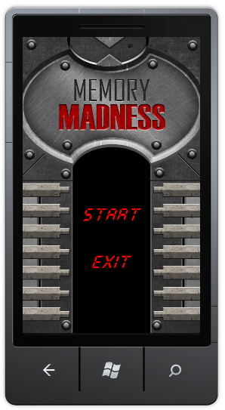
Figure 7
The game’s main menu
  - The final part of this task is to add an additional screen, the pause screen. Create a new class under the “Screens” folder and call it “PauseScreen”.
  - Open the new class file and add the following using statements at the top of the file.
C#
using GameStateManagement;
using Microsoft.Xna.Framework;
  - Change the newly created class to inherit from the “MenuScreen” class:
C#
class PauseScreen : MenuScreen
{
}
  - Add the following fields to the PauseScreen class:
C#
bool isResuming;
The purpose of the preceding field will become evident as we implement more of the lab.
  - Add the following constructor to the class:
C#
public PauseScreen(bool isResuming)
: base("Pause")
{
// Create our menu entries.
MenuEntry returnGameMenuEntry = new MenuEntry("Return");
MenuEntry exitMenuEntry = new MenuEntry("Quit");
// Hook up menu event handlers.
returnGameMenuEntry.Selected += ReturnGameMenuEntrySelected;
exitMenuEntry.Selected += OnCancel;
// Add entries to the menu.
MenuEntries.Add(returnGameMenuEntry);
MenuEntries.Add(exitMenuEntry);
this.isResuming = isResuming;
AudioManager.PauseResumeSounds(false);
}
The PauseScreen’s constructor remembers the value of the isResuming argument. We will use this variable to introduce different resuming logic when resuming from a simple pause and when returning to the game after saving its state and leaving it. Additionally, all currently playing sounds will be paused.
  - Add the following two event handlers to the class:
C#
void ReturnGameMenuEntrySelected(object sender, EventArgs e)
{
//TODO #3
AudioManager.PauseResumeSounds(true);
// Select all the screens beside GameplayScreen and close them
var screens = ScreenManager.GetScreens();
foreach (GameScreen screen in screens)
{
if (!(screen is GameplayScreen))
{
screen.ExitScreen();
}
}
(ScreenManager.GetScreens()[0] as GameplayScreen).IsActive = true;
}
protected override void OnCancel(PlayerIndex playerIndex)
{
AudioManager.StopSounds();
//TODO #4
foreach (GameScreen screen in ScreenManager.GetScreens())
screen.ExitScreen();
ScreenManager.AddScreen(new BackgroundScreen(false), null);
ScreenManager.AddScreen(new MainMenuScreen(), null);
}

Notice how the first handler, which is fired when the user wishes to return to the game, restores the IsActive value and resumes all paused sounds.
  - The final step is to revise the GameplayScreen class to utilize the new pause screen. Open GameplayScreen.cs and navigate to the “HandleInput” method. Locate “//TODO #7” placeholder and replace it with the following:
C#
if (input.IsPauseGame(null))
{
PauseCurrentGame();
}
  - Create two helper methods – “PauseCurrentGame” and “FinishCurrentGame” according to the following code snippet:
C#
private void FinishCurrentGame()
{
isActive = false;
//TODO #1
moveToHighScore = true;
}
private void PauseCurrentGame()
{
IsActive = false;
// Pause sounds
AudioManager.PauseResumeSounds(false);
ScreenManager.AddScreen(new BackgroundScreen(false), null);
ScreenManager.AddScreen(new PauseScreen(false), null);
}

  - Navigate to the “Update” method. Locate “//TODO #8” and add the following code snipper right below the placeholder:
C#
if ((moveToHighScore) && (!AudioManager.AreSoundsPlaying()))
{
ScreenManager.Game.Components.Remove(currentLevel);
foreach (GameScreen screen in ScreenManager.GetScreens())
screen.ExitScreen();
// TODO #8A
ScreenManager.AddScreen(new BackgroundScreen(false), null);
ScreenManager.AddScreen(new MainMenuScreen(), null);
}

  - Next, navigate to the “//TODO #10” placeholder and replace the game exit call with the following code:
C#
FinishCurrentGame();

  - Compile and deploy the project. From the gameplay screen, you should now be able to use the back arrow key on the device to pause the game. The pause menu allows you to return to the game or exit to the main menu.
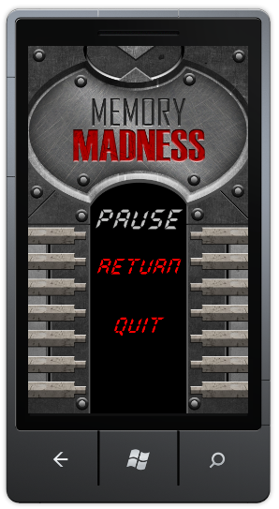
Figure 8
Pause screen
  - This step concludes the task. In next task, we will add a high-score screen and store the high-scores in the phone’s stoarge.

Task 3 – Keeping the HighScore
  - Create a new class under the “Screens” folder and call it “HighScoreScreen”.
  - Open the new class file and add the following using statements at the top of the file.
C#
using System.IO.IsolatedStorage;
using System.IO;
using Microsoft.Xna.Framework.Graphics;
using Microsoft.Xna.Framework;
using GameStateManagement;
using Microsoft.Xna.Framework.Input.Touch;

  - Change the new class to derive from the “GameScreen” class:
C#
class HighScoreScreen : GameScreen
{

}
  - Add the following fields to the class:
C#
const int highscorePlaces = 10;
public static List<KeyValuePair<string, int>> highScore =
new List<KeyValuePair<string, int>>(highscorePlaces)
{
new KeyValuePair<string, int>("Jasper",10),
new KeyValuePair<string, int>("Ellen",9),
new KeyValuePair<string, int>("Terry",8),
new KeyValuePair<string, int>("Lori",7),
new KeyValuePair<string, int>("Michael",6),
new KeyValuePair<string, int>("Carol",5),
new KeyValuePair<string, int>("Toni",4),
new KeyValuePair<string, int>("Cassie",3),
new KeyValuePair<string, int>("Luca",2),
new KeyValuePair<string, int>("Brian",1)
};
SpriteFont highScoreFont;
These fields define the size of the high score table and provide a set of default entries.
  - Add the following constructor to the HighScoreScreen class:
C#
public HighScoreScreen()
{
EnabledGestures = GestureType.Tap;
}
  - Override the LoadContent method with the following code:
C#
public override void LoadContent()
{
highScoreFont = Load<SpriteFont>(@"Fonts\HighScoresFont");
base.LoadContent();
}
  - Override HandleInput with the following code:
C#
public override void HandleInput(InputState input)
{
if (input == null)
throw new ArgumentNullException("input");
if (input.IsPauseGame(null))
{
Exit();
}
// Return to the main menu when a tep gesture is recognized
if (input.Gestures.Count > 0)
{
GestureSample sample = input.Gestures[0];
if (sample.GestureType == GestureType.Tap)
{
Exit();
input.Gestures.Clear();
}
}
}
This will cause the screen to exit when the user taps the display or uses the device’s “back” button. Exiting the screen is handled by the “Exit” method, which we will implement next.
  - Add the following method to exit the high score screen:
C#
private void Exit()
{
this.ExitScreen();
ScreenManager.AddScreen(new BackgroundScreen(false), null);
ScreenManager.AddScreen(new MainMenuScreen(), null);
}
  - Override the Draw method to show the highscores table on the screen:
C#
public override void Draw(Microsoft.Xna.Framework.GameTime gameTime)
{
ScreenManager.SpriteBatch.Begin();
// Draw the title
string text = "High Scores";
var textSize = highScoreFont.MeasureString(text);
var position = new Vector2(ScreenManager.GraphicsDevice.Viewport.Width / 2
- textSize.X / 2, 340);
ScreenManager.SpriteBatch.DrawString(highScoreFont, text,
position, Color.Red);
// Draw the highscores table
for (int i = 0; i < highScore.Count; i++)
{
ScreenManager.SpriteBatch.DrawString(highScoreFont,
String.Format("{0,2}. {1}", i + 1, highScore[i].Key),
new Vector2(50, i * 40 + position.Y + 40), Color.YellowGreen);
ScreenManager.SpriteBatch.DrawString(highScoreFont,
highScore[i].Value.ToString(),
new Vector2(370, i * 40 + position.Y + 40),
Color.YellowGreen);
}
ScreenManager.SpriteBatch.End();
base.Draw(gameTime);
}
So far, we have added very little logic to the screen that actually manages the high-score table. Let us focus on supporting the high-scores data now. Please note that since high-score management is performed across game screens, it will be implemented as "static" methods and fields.
  - Add the following method to the HighScoreScreen class. It will check if a score belongs in the high-score table by comparing it with the worst score on the table:
C#
public static bool IsInHighscores(int level)
{
// If the score is higher than the worst score in the table
return level > highScore[highscorePlaces - 1].Value;
}
  - Add an additional method which orders the scores in the high-score table:
C#
private static void OrderGameScore()
{
highScore.Sort(CompareScores);
}
The high-score table is ordered by level number.
  - Add the following comparison method used in the sorting operation above:
C#
private static int CompareScores(KeyValuePair<string, int> score1,
KeyValuePair<string, int> score2)
{
if (score1.Value < score2.Value)
{
return 1;
}
if (score1.Value == score2.Value)
{
return 0;
}
return -1;
}
Note: For an explanation regarding comparison method return values, see: http://msdn.microsoft.com/en-us/library/tfakywbh.aspx
  - Add a method to insert new scores into the high-score table:
C#
public static void PutHighScore(string playerName, int level)
{
if (IsInHighscores(level))
{
highScore[highscorePlaces - 1] =
new KeyValuePair<string, int>(playerName, level);
OrderGameScore();
}
}

A new score is inserted by removing the lowest score and then ordering the table
  - Add the following method to store the high-score table on the device:
C#
public static void SaveHighscore()
{
// Get the place to store data
using (IsolatedStorageFile isf =
IsolatedStorageFile.GetUserStoreForApplication())
{
// Create a file to save the highscore data
using (IsolatedStorageFileStream isfs =
isf.CreateFile("highscores.txt"))
{
using (StreamWriter writer = new StreamWriter(isfs))
{
for (int i = 0; i < highScore.Count; i++)
{
// Write the scores
writer.WriteLine(highScore[i].Key);
writer.WriteLine(highScore[i].Value.ToString());
}
}
}
}
}
Note that we first access the game’s isolated storage, which is the only place where the game is allowed to store data on the device.
  - Add the following method to load the high-score table:
C#
public static void LoadHighscores()
{
// Get the place where data is stored
using (IsolatedStorageFile isf =
IsolatedStorageFile.GetUserStoreForApplication())
{
// Try to open the file
if (isf.FileExists("highscores.txt"))
{
using (IsolatedStorageFileStream isfs =
isf.OpenFile("highscores.txt", FileMode.Open))
{
// Get the stream to read the data
using (StreamReader reader = new StreamReader(isfs))
{
// Read the highscores
int i = 0;
while (!reader.EndOfStream)
{
string name = reader.ReadLine();
int score = int.Parse(reader.ReadLine());
highScore[i++] = new KeyValuePair<string, int>(name, score);
}
}
}
}
}
OrderGameScore();
}

When loading the high-score table we attempt to find the file created by the save operation in the game’s isolated storage. If the file does not exist, the high-score table will revert to its default values.
  - The high-score screen is now ready, we just need to initialize it. Open the “MemoryMadnessGame.cs” file and navigate to the LoadContent method.
Alter the method in the following manner:
C#
protected override void LoadContent()
{
AudioManager.LoadSounds();
HighScoreScreen.LoadHighscores();
base.LoadContent();
}

  - Open “MainMenuScreen” and navigate to class constructor. Alter the method by adding a new menu entry – High Scores. The final method code should be like the following (old code is gray):
C#
// Create our menu entries.
MenuEntry startGameMenuEntry = new MenuEntry("Start");
MenuEntry highScoreMenuEntry = new MenuEntry("High scores");
MenuEntry exitMenuEntry = new MenuEntry("Exit");
// Hook up menu event handlers.
startGameMenuEntry.Selected += StartGameMenuEntrySelected;
highScoreMenuEntry.Selected += HighScoreMenuEntrySelected;
exitMenuEntry.Selected += OnCancel;
// Add entries to the menu.
MenuEntries.Add(startGameMenuEntry);
MenuEntries.Add(highScoreMenuEntry);
MenuEntries.Add(exitMenuEntry);

  - Add a new event handler method to handle “High scores” menu item selection:
C#
void HighScoreMenuEntrySelected(object sender, EventArgs e)
{
foreach (GameScreen screen in ScreenManager.GetScreens())
screen.ExitScreen();
ScreenManager.AddScreen(new BackgroundScreen(true), null);
ScreenManager.AddScreen(new HighScoreScreen(), null);
}

Note: In this case the BackgroundScreen constructor receives true in the parameter and will produce the “sliding doors” animation while presenting the screen.
  - Navigate to the “//TODO #4” placeholer and add the following code after it:
C#
HighScoreScreen.SaveHighscore();

  - Open “GameplayScreen.cs” and navigate to the “//TODO #8A” placeholder. Replace the two lines of the code below the placeholder with the following code snippet:
C#
ScreenManager.AddScreen(new BackgroundScreen(true), null);
ScreenManager.AddScreen(new HighScoreScreen(), null);

  - Navigate to the “FinishCurrentGame” method and change it according to the following code snippet (replace the code beneath “//TODO #1” so as to end up with the following):
C#
private void FinishCurrentGame()
{
isActive = false;
if (HighScoreScreen.IsInHighscores(currentLevelNumber))
{
// Show the device's keyboard to enter a name for the highscore
Guide.BeginShowKeyboardInput(PlayerIndex.One,
Constants.HighscorePopupTitle, Constants.HighscorePopupText,
Constants.HighscorePopupDefault, ShowHighscorePromptEnded, true);
}
else
{
moveToHighScore = true;
}
}
The following code snippet checks if the user is eligible to enter to the high-score table, and if so, presents a prompt to enter the user’s name. The constants used are found in the “Settings.cs” file we have added as an asset at an earlier point. After the user has entered a name, the “ShowHighscorePromptEnded” callback is invoked.
  - Implement the “ShowHighscorePromptEnded” callback by adding the following method to the GameplayScreen class:
C#
private void ShowHighscorePromptEnded(IAsyncResult result)
{
string playerName = Guide.EndShowKeyboardInput(result);
bool finishedGame = (bool)result.AsyncState;
if (playerName != null)
{
if (playerName.Length > 15)
playerName = playerName.Substring(0, 15);
HighScoreScreen.PutHighScore(playerName, currentLevelNumber);
}
if (finishedGame)
{
moveToHighScore = true;
}
else
{
AudioManager.PlaySound("fail");
isActive = true;
currentLevelNumber = 1;
isLevelChange = true;
}
}
This callback stores the user’s highscore and either resets the game to level 1 or causes it to move to the highscore screen.
  - Navigate to the “Update” method and locate the “// TODO #11” marker comment. Change the enclosing block of code to the following:
C#
else if (currentLevel.CurrentState == LevelState.FinishedFail)
{
isActive = false;
if (HighScoreScreen.IsInHighscores(currentLevelNumber))
{
// The player has a highscore - show the device's keyboard
Guide.BeginShowKeyboardInput(PlayerIndex.One,
Constants.HighscorePopupTitle, Constants.HighscorePopupText,
Constants.HighscorePopupDefault, ShowHighscorePromptEnded,
false);
}
else
{
AudioManager.PlaySound("fail");
isActive = true;
currentLevelNumber = 1;
isLevelChange = true;
}
}
This will give the player a chance to register a high score once failing a level if he is elligable for a high score.
  - Compile and deploy the game. Now the main menu has an additional entry – “High Scores”. Selecting this option, will take you to the High Score screen.
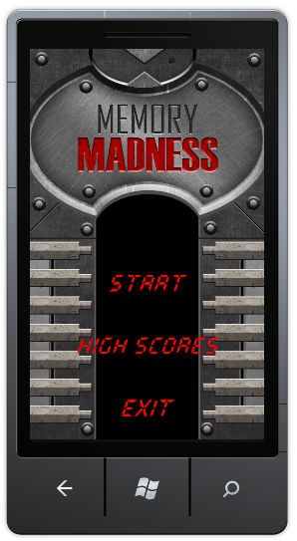
Figure 9
Updated Main Menu
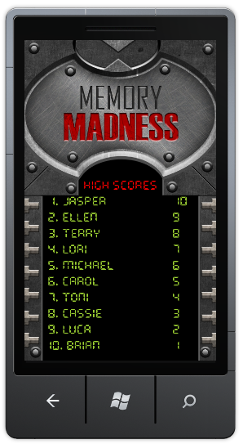
Figure 10
High Scores screen
Note the “sliding doors” animation while opening the screen
  - If you achieve a high-score at the end of a game, observe the on-screen keyboard presented by the game.
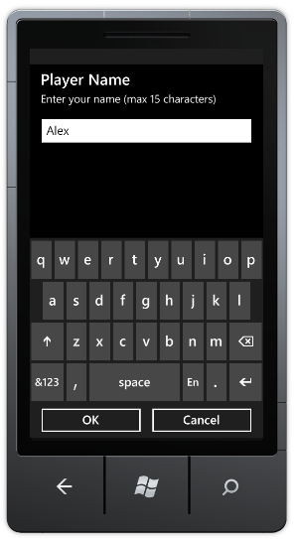
Figure 11
On-screen keyboard for high-score name entry
  - Now the high-score screen has a new entry in the table.
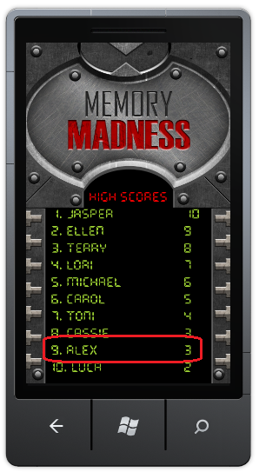
Figure 12
High scores with the new entry
  - Now the game is almost fully operational. The last thing left is to add a functionality to resume the game after interruption. We will take care of it in the next task.

Task 4 – Saving/Loading game state
The Windows Phone execution model governs the life cycle of applications running on a Windows Phone, from the time the application is launched, until it is terminated.
The execution model is designed to provide end users with a fast, responsive experience at all times. To achieve this, Windows Phone allows only one application to run at a time. This eliminates the possibility of users getting their device into a state where multiple applications are running in the background, causing the application in the foreground to become sluggish. In addition to responsiveness, the execution model provides users with a consistent navigation experience between applications. On Windows Phone 7, users navigate forward by launching applications. Users can also navigate backwards, through the pages of a running application, or through the stack of previously running applications, by using the device’s Back button.
To enable seamless navigation by limiting the phone to run one application at a time, Windows Phone 7 activates and deactivates applications dynamically, exposing events for developers to respond to when the application state changes. By implementing handlers for these events, developers can save and restore the application state as their application transitions between active and inactive states. This behavior creates an experience in which the user believes the application continued to run in the background.
It is important to note that an application is not guaranteed to activate after being deactivated (it may be terminated completely instead), so all critical information must be stored in persistent storage when the application is deactivated. This will allow restoring the data when application is launched next.
In the course of this task, we will add activation/deactivation support to the game. When the user navigates away from the application, the game will suggest saving the current progress. If the user opts to do so, the current level number is saved in the device’s Isoalted Storage so that when the game starts next, the user will be able to keep playing from the saved level.
  - Add a reference to the Microsoft.Phone and System.Windows assemblies to the MemoryMadness project.
  - Open MemoryMadnessGame.cs and add the following using statements at the beginning of the class:
C#
using System.IO.IsolatedStorage;
using System.IO;
using Microsoft.Phone.Shell;

  - Navigate to the class’ constructor add the following code at the end of the method:
C#
// Subscribe to application's lifecycle events
PhoneApplicationService.Current.Activated += GameActivated;
PhoneApplicationService.Current.Deactivated += GameDeactivated;
PhoneApplicationService.Current.Closing += GameClosing;
PhoneApplicationService.Current.Launching += GameLaunching;

These events will allow the game to respond to different application’s lifecycle events.
  - The Launching event occurs when brand new instance of the application is activated.
  - In our game, we will check Isolated Storage for a well-known file with saved progress. If the file is found we will read its information and allow the user to resume from the stored level number.
  - The Closing even corresponds to the application’s closing, when the user navigates away from the application and it is “killed”.
  - In our game, we will save the current level progress to Isolated Storage if the user decides to do so.
  - The Activated event occurs when the application is reactivated from idle state. In this case, the application receives a state object, which could have application specific values. These values are stored during application’s Deactivated event.
  - In our game, we will check the state object for specific value which represent progress within a specific level.
  - The Deactivated event occurs when the application is deactivated. Deactivation occurs when the user navigates away from application by pressing the Windows button by some external event such as incoming phone call, launcher/chooser work, etc.
Note: The Launchers and Choosers framework enables Windows Phone applications to provide a set of common tasks to their users, such as placing phone calls, sending email and taking pictures. Windows Phone exposes a set of APIs referred to as Launchers and Choosers that allow applications indirect access to these useful phone features. The Launcher and Chooser APIs invoke distinct built-in applications that replace the currently running application. When implemented correctly, the Launchers and Choosers framework can provide the end user with a seamless experience in which it is not apparent that they are switching between applications.
This lab does not in cover the Launchers and Choosers. For more information about them please refer to MSDN documentation (http://msdn.microsoft.com/en-us/library/ff769556(v=VS.92).aspx).
  - In our game, the current level will be preserved in Isolated Storage and current sequence progress will be saved in the state object. This enables our application to restore its state.
  - Create event handler methods according to the following code snippet:
C#
void GameDeactivated(object sender, DeactivatedEventArgs e)
{
SaveToStateObject();
if (PhoneApplicationService.Current.State.ContainsKey("CurrentLevel"))
{
SaveToIsolatedStorage(
(int)PhoneApplicationService.Current.State["CurrentLevel"]);
PhoneApplicationService.Current.State.Remove("CurrentLevel");
}
}
void GameActivated(object sender, ActivatedEventArgs e)
{
LoadFromStateObject();
LoadFromIsolatedStorage();
}
void GameClosing(object sender, ClosingEventArgs e)
{
if (PhoneApplicationService.Current.State.ContainsKey("CurrentLevel"))
{
SaveToIsolatedStorage(
(int)PhoneApplicationService.Current.State["CurrentLevel"]);
PhoneApplicationService.Current.State.Remove("CurrentLevel");
}
else
CleanIsolatedStorage();
}
void GameLaunching(object sender, LaunchingEventArgs e)
{
LoadFromIsolatedStorage();
}

  - The methods above are using helper methods to simplify the initial implementation. Please add the following code snippet with required helper methods to complete the class functionality:
C#
/// <summary>
/// Saves current gameplay progress to the state object
/// </summary>
private void SaveToStateObject()
{
// Get the gameplay screen object
GameplayScreen gameplayScreen = GetGameplayScreen();
if (null != gameplayScreen)
{
// If gameplay screen object found save current game progress to
// the state object
PhoneApplicationService.Current.State["MovesPerformed"] =
gameplayScreen.currentLevel.MovesPerformed;
PhoneApplicationService.Current.State["CurrentLevel"] =
gameplayScreen.currentLevel.levelNumber;
}
}
/// <summary>
/// Loads the game progress from the state object if such information exits.
/// </summary>
private void LoadFromStateObject()
{
int sequenceProgress = 0;
// Check state object for sequence progress and load it if found
if (!PhoneApplicationService.Current.State.ContainsKey("MovesPerformed"))
PhoneApplicationService.Current.State["MovesPerformed"] =
sequenceProgress;
}
/// <summary>
/// Saves the level progress to isolated storage
/// </summary>
/// <param name="currentLevel">The level number to save</param>
private void SaveToIsolatedStorage(int currentLevel)
{
// Get Isolated Storage for current application
using (IsolatedStorageFile isolatedStorageFile
= IsolatedStorageFile.GetUserStoreForApplication())
{
// Create/overwrite file and save provided value
using (IsolatedStorageFileStream fileStream
= isolatedStorageFile.CreateFile("MemoryMadness.dat"))
{
using (StreamWriter streamWriter = new StreamWriter(fileStream))
{
streamWriter.WriteLine(currentLevel);
}
}
}
}
/// <summary>
/// Clean isolated storage from previously saved information
/// </summary>
private void CleanIsolatedStorage()
{
using (IsolatedStorageFile isolatedStorageFile
= IsolatedStorageFile.GetUserStoreForApplication())
{
isolatedStorageFile.DeleteFile("MemoryMadness.dat");
}
}
/// <summary>
/// Loads game progress from isolated storage file if it exits
/// </summary>
private void LoadFromIsolatedStorage()
{
int currentLevel = 1;
// Get the isolated storage for the current application
using (IsolatedStorageFile isolatedStorageFile
= IsolatedStorageFile.GetUserStoreForApplication())
{
// Check whether or not the data file exists
if (isolatedStorageFile.FileExists("MemoryMadness.dat"))
{
// If the file exits, open it and read its information
using (IsolatedStorageFileStream fileStream
= isolatedStorageFile.OpenFile("MemoryMadness.dat",
FileMode.Open))
{
using (StreamReader streamReader = new StreamReader(fileStream))
{
if (!int.TryParse(streamReader.ReadLine(), out currentLevel))
currentLevel = 1;
}
}
}
}
PhoneApplicationService.Current.State["CurrentLevel"] = currentLevel;
}
/// <summary>
/// Find gameplay screen objects among all screens and return one if any are
/// found.
/// </summary>
/// <returns>A gameplay screen instance.</returns>
private GameplayScreen GetGameplayScreen()
{
var screens = screenManager.GetScreens();
foreach (var screen in screens)
{
if (screen is GameplayScreen)
{
return screen as GameplayScreen;
}
}
return null;
}
  - While resuming the game after deactivation, we will present a different loading experience. Open “LoadingAndInstructionsScreen.cs” and add the following using statement to the top of the file:
C#
using Microsoft.Phone.Shell;
  - Navigate to the constructor. Locate “//TODO #1” placeholder and place the following code snippet below it:
C#
if (PhoneApplicationService.Current.State.ContainsKey("CurrentLevel"))
{
this.levelNumber =
(int)PhoneApplicationService.Current.State["CurrentLevel"];
PhoneApplicationService.Current.State.Remove("CurrentLevel");
}
if (PhoneApplicationService.Current.State.ContainsKey("MovesPerformed"))
{
this.movesPerformed =
(int)PhoneApplicationService.Current.State["MovesPerformed"];
PhoneApplicationService.Current.State.Remove("MovesPerformed");
}
  - The last thing to do is alter the pause screen to support the Activation/Deactivation cycle. Open “PauseScreen.cs” and add the following using statements at the top of the class after last using statement:
C#
using Microsoft.Phone.Shell;
using Microsoft.Xna.Framework.GamerServices;
  - Locate “//TODO #1” placeholder and add the following variables definition to the class:
C#
bool checkHighscore = false;
bool moveToHighScore = false;
bool moveToMainMenu = false;
  - Navigate to the class constructor and alter its end according to the following code snipped (old code is colored gray):
C#
...
MenuEntries.Add(returnGameMenuEntry);
MenuEntries.Add(exitMenuEntry);
this.isResuming = isResuming;
if (!isResuming)
AudioManager.PauseResumeSounds(false);
}
Pausing/Resuming the sounds is only relevant when paused from the gameplay state and not resuming from saved state.
  - Override the “LoadContend” method of the class according to the following code snippet:
C#
public override void LoadContent()
{
if (isResuming && !AudioManager.IsInitialized)
AudioManager.LoadSounds();
AudioManager.PlaySound("menu");
base.LoadContent();
}
This method initializes the Audio Manager in case the game initialized via the “Activated” path.
  - Override the “Update” method to handle leaving the game and saving the high score correctly:
C#
public override void Update(GameTime gameTime, bool otherScreenHasFocus, bool coveredByOtherScreen)
{
if (checkHighscore && (!Guide.IsVisible))
{
checkHighscore = false;
var gameplayScreen = GetGameplayScreen();
var levelNumber = gameplayScreen.currentLevel.levelNumber;
if (HighScoreScreen.IsInHighscores(levelNumber))
{
// Show the device's keyboard to record a high score
Guide.BeginShowKeyboardInput(PlayerIndex.One,
Constants.HighscorePopupTitle, Constants.HighscorePopupText,
Constants.HighscorePopupDefault, ShowHighscorePromptEnded, levelNumber);
}
else
{
moveToMainMenu = true;
}
}
else if (moveToHighScore)
{
foreach (GameScreen screen in ScreenManager.GetScreens())
screen.ExitScreen();
ScreenManager.AddScreen(new BackgroundScreen(true), null);
ScreenManager.AddScreen(new HighScoreScreen(), null);
}
else if (moveToMainMenu)
{
foreach (GameScreen screen in ScreenManager.GetScreens())
screen.ExitScreen();
ScreenManager.AddScreen(new BackgroundScreen(false), null);
ScreenManager.AddScreen(new MainMenuScreen(), null);
}
base.Update(gameTime, otherScreenHasFocus, coveredByOtherScreen);
}

  - For the above method to work, we must introduce the “GetGameplayScreen” and “ShowHighscorePromptEnded” methods, which are variants of similarly named methods we have encountered previously in this lab:
C#
private void ShowHighscorePromptEnded(IAsyncResult result)
{
string playerName = Guide.EndShowKeyboardInput(result);
int levelNumber = (int)result.AsyncState;
if (playerName != null)
{
if (playerName.Length > 15)
playerName = playerName.Substring(0, 15);
HighScoreScreen.PutHighScore(playerName, levelNumber);
}
moveToHighScore = true;
}
private GameplayScreen GetGameplayScreen()
{
var screens = ScreenManager.GetScreens();
foreach (var screen in screens)
{
if (screen is GameplayScreen)
{
return screen as GameplayScreen;
}
}
return null;
}
  - Navigate to “ReturnGameMenuEntrySelected” and alter it according to the following code snippet:
C#
void ReturnGameMenuEntrySelected(object sender, EventArgs e)
{
if (!isResuming)
{
// Resume sounds and activate the gameplay screen
AudioManager.PauseResumeSounds(true);
var screens = ScreenManager.GetScreens();
foreach (GameScreen screen in screens)
{
if (!(screen is GameplayScreen))
{
screen.ExitScreen();
}
}
(ScreenManager.GetScreens()[0] as GameplayScreen).IsActive = true;
}
else
{
// Since we are resuming the game, go to the loading screen which will
// in turn initialize the gameplay screen
foreach (GameScreen screen in ScreenManager.GetScreens())
screen.ExitScreen();
ScreenManager.AddScreen(new LoadingAndInstructionsScreen(true), null);
}
}
Note: New code is bold. It allows resuming a game via loading screen in case the game resumed after deactivation.
  - Navigate to the “OnCancel” method and alter it according to the following code snippet (old code is colored gray):
C#
protected override void OnCancel(PlayerIndex playerIndex)
{
AudioManager.StopSounds();
// Give the user a chance to save his current progress
Guide.BeginShowMessageBox("Save Game", Do you want to save your progress?",
new String[] { "Yes", "No" }, 0, MessageBoxIcon.Warning,
ShowSaveDialogEnded, null);
}
This function allows user to save current game progress (level number) before leaving a game.
  - Implement the callback used by the above method:
C#
private void ShowSaveDialogEnded(IAsyncResult result)
{
int? res = Guide.EndShowMessageBox(result);
if (res.HasValue)
{
// Store the user's progress
if (res.Value == 0)
{
if (!PhoneApplicationService.Current.State.ContainsKey(
"CurrentLevel"))
{
var gameplayScreen = GetGameplayScreen();
PhoneApplicationService.Current.State["CurrentLevel"]
= gameplayScreen.currentLevel.levelNumber;
}
foreach (GameScreen screen in ScreenManager.GetScreens())
screen.ExitScreen();
ScreenManager.AddScreen(new BackgroundScreen(false), null);
ScreenManager.AddScreen(new MainMenuScreen(), null);
}
// The user really quit the game, see if he has a high score
else
{
checkHighscore = true;
}
}
}
If the user chooses to save his progress then it is saved and his score is not entered into the highscore table as it is assumed he will continue playing at a later point. Otherwise, if the player has reached a new high score, it is entered to the highscore table.
  - We will now add one final screen class that we will use to allow the user to decide whether to resume a saved game or simply start a new one. Create a new class named “NewGameSubMenu” under the “Screens” project folder.
  - Add the following using statements to the newly created file:
C#
using Microsoft.Xna.Framework;
using GameStateManagement;
using Microsoft.Phone.Shell;
  - Now simply change the class to the following:
C#
class NewGameSubMenuScreen : MenuScreen
{
public NewGameSubMenuScreen()
: base("")
{
// Create our menu entries.
MenuEntry newGameMenuEntry = new MenuEntry("New Game");
MenuEntry loadGameMenuEntry = new MenuEntry("Load");
// Hook up menu event handlers.
newGameMenuEntry.Selected += NewGameMenuEntrySelected;
loadGameMenuEntry.Selected += LoadGameMenuEntrySelected;
// Add entries to the menu.
MenuEntries.Add(newGameMenuEntry);
MenuEntries.Add(loadGameMenuEntry);
}
void LoadGameMenuEntrySelected(object sender, EventArgs e)
{
foreach (GameScreen screen in ScreenManager.GetScreens())
screen.ExitScreen();
ScreenManager.AddScreen(new LoadingAndInstructionsScreen(false),
null);
}
void NewGameMenuEntrySelected(object sender, EventArgs e)
{
if (PhoneApplicationService.Current.State.ContainsKey("CurrentLevel"))
{
PhoneApplicationService.Current.State.Remove("CurrentLevel");
}
LoadGameMenuEntrySelected(sender, e);
}
protected override void OnCancel(PlayerIndex playerIndex)
{
foreach (GameScreen screen in ScreenManager.GetScreens())
screen.ExitScreen();
ScreenManager.AddScreen(new BackgroundScreen(false), null);
ScreenManager.AddScreen(new MainMenuScreen(), null);
}
}
Most of the above code should be familiar by now. This new menu screen simply moves on to the loading screen, making sure to remove current level information if a new game is desired. Pressing the back button will return to the main menu.
  - We must change the main menu to use the sub-menu we have just introduced. Open the “MainMenuScreen.cs” file under the “Screens” project folder, find the “StartGameMenuEntrySelected” method and change it to the following:
C#
void StartGameMenuEntrySelected(object sender, EventArgs e)
{
foreach (GameScreen screen in ScreenManager.GetScreens())
screen.ExitScreen();
// if a saved game exists, let the user decide whether or not to use it
// by moving to a sub-menu
if (PhoneApplicationService.Current.State.ContainsKey("CurrentLevel") &&
(int)PhoneApplicationService.Current.State["CurrentLevel"] > 1)
{
ScreenManager.AddScreen(new BackgroundScreen(false), null);
ScreenManager.AddScreen(new NewGameSubMenuScreen(), null);
}
else
{
ScreenManager.AddScreen(new LoadingAndInstructionsScreen(false),
null);
}
}
This will advance the user to the new game sub-menu only if saved game data exists.
  - Last, but not least, we must create a different start-up path for the application. In case of new instance launch the aplication should startup normally, but in case of re-activation it should start up from pause screen instead of main menu. Open “MemoryMandnessGame.cs”, navigate to the class constructor,locate the “MainMenuScreen” creation and change it to the following code snippet:
C#
...
screenManager.AddScreen(new BackgroundScreen(false), null);
if (PhoneApplicationService.Current.StartupMode == StartupMode.Launch)
screenManager.AddScreen(new MainMenuScreen(), null);
else
screenManager.AddScreen(new PauseScreen(true), null);
// Subscribe to application's lifecycle events
PhoneApplicationService.Current.Activated += GameActivated;
...
  - To check the new functionality, compile and launch the game. Progress through the game until the level changes (pass at least one level) and press the Back key. On the Pause screen select the “Quit” option and when presented with a question to save game progress click “yes”.
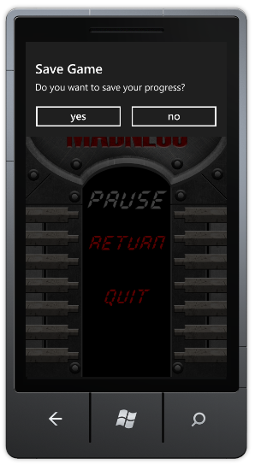
Figure 13
Save Game dialog
The game navigates to the main screen. Select “Exit” to exit the game.
Restart the game from the Visual Studio. Select “Start” and you should advance to the new game sub-menu.
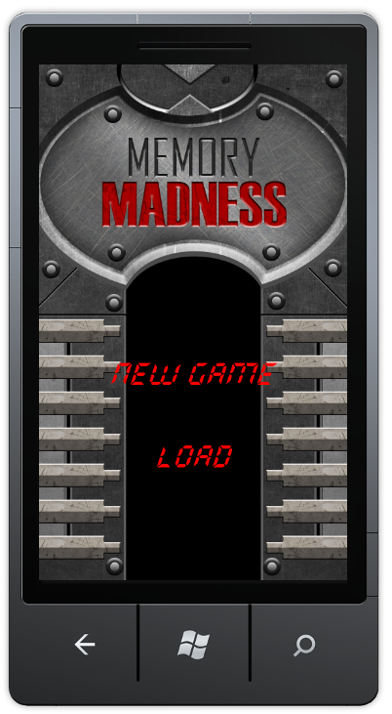
Figure 14
New game sub-menu
Selecting “Load”, you will see the game resume from the level previously saved.
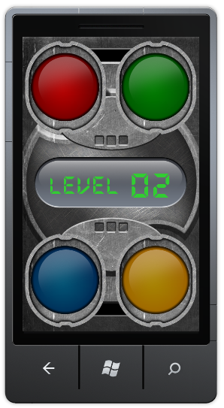
Figure 15
Game resumed to saved level
Progress through the game to next level and press the Back button again. On Pause screen select “Quit” option and when presented with a question to save a game progress click “no”. The game navigates to the main screen. On the main screen, select “Exit” to exit the game.
Note: If your current gameplay progress makes it to the high-score table, the game prompts the user to enter his name (as discussed in Task 3).
Restart the game from Visual Studio. Selecting “Start” should now advance directly to the loading screen then the gameplay screen, which should display the first level.
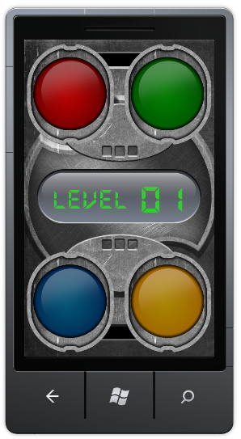
Figure 16
The game started from the first level
Progress through the game. Let the game present the current sequence and repeat some of the steps. Remember your current progress through the sequence and press Windows key. The game exits immediately to the phone’s main screen but Visual Studio is still in debugging mode.
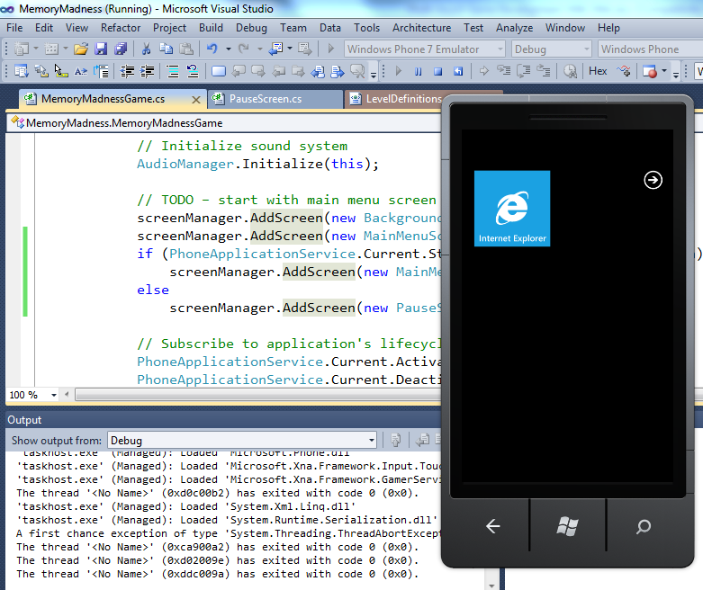
Figure 17
Game deactivated
Now press the Back key in the emulator. The game resumes and navigates automatically to the Pause screen.
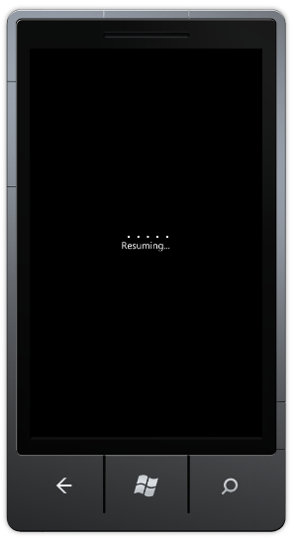
Figure 18
The game resumes from deactivated state
Figure 19
Pause screen presented after resume complete
Select “Return”. You should be able to continue the sequence from where you left off and successfully finish the level.
  - This step completes the task and the lab.
Congratulations! The game is now fully operational.

Summary
This lab introduced you to developing applications for the Windows Phone 7™ platform using the XNA Framework. In the course of this lab, you created an XNA Game Studio project for Windows Phone 7, loaded the game’s resources, took care of the multi-touch input, updated the game state and added game specific logic.
By completing this hands-on lab, you also became familiar with the tools required to create and test an XNA Game Studio project for Windows Phone.

